What do YOU think the teens in South Providence will be doing this summer?

With your help, many of them will be part of a 9 week program at Louie’s Place Summer Camp, (a licensed, full-day camp for children 5-17).

In addition to helping our summer staff provide attention and supervision to nearly 100 kids, our Youth Leadership Development and Jr. Counselor Participants will benefit from the following target areas:
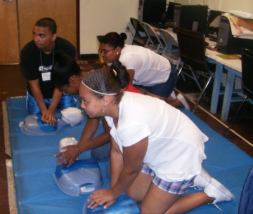
Work Readiness: Interview/Resume Skills, Computer Literacy, Professional Behaviors
Training/Workshops: Food Safety, Disease control and Prevention,
CPR/First Aid, Conflict Resolution and Non-Violent Problem Solving
Educational Support and Life Skills: Financial Literacy and Money Management, Public Speaking, College Planning, Skills and Interest Assessments, Career Exploration

By the end of the summer most of our teens will have volunteered over 400 hours of service! They will also gain valuable work and life experience. Each one will have the opportunity to work with different age groups, in a variety of activities, including sports, games, literacy, arts & crafts, cooking, and more. They will also be responsible for at least one original presentation to the campers on a topic of their choice. Some examples are Substance Abuse Prevention, Staying in School, Nutrition and Healthy Lifestyles.

We would like to offer our teens a weekly stipend for their service. Stipends usually range from $50-$150/week, based on time and level of responsibility.
“Everything I learned as a Jr. Counselor has helped me in ALL areas of my life; at home, with friends, at work, and in college!”
-Jacinto Diaz, RIC freshman

Please consider sponsoring a leader for our program this summer.
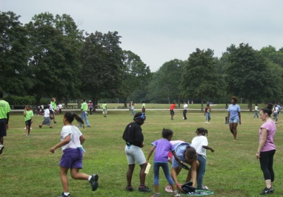
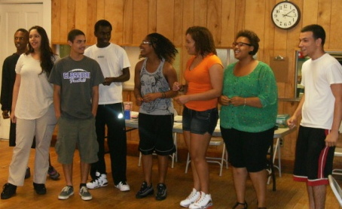
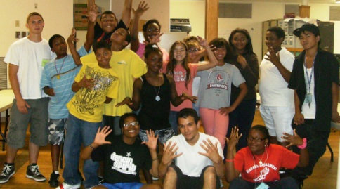
For more information, contact Amy Thomas, Youth Program Coordinator, South Providence Neighborhood Ministries (401) 461-7509 or amy@spnm.org

